Meije Manon LAURET, Antoine FUCHS, Raphaël GAULTIER

**The main trends of environmental concern since 2001**

*Word analysis of* Le Monde*’s articles: specific terms’ popularity as markers for political and social dynamics about environmental issues*

The words used to talk about a specific topic reflect a particular state of mind of the population, particular social and political dynamics about the subject in the concerned country. To take a recent example, we can think in France about the rise of the term "woke" or the term "islamo-gauchisme" (Islamo-leftism). These terms reflect a state of mind of a specific part of the population that accuses a part of the left of being responsible for the current problems in France.

We decided to focus on the ecological issue. It seemed interesting to us, because ecology is often referred to as the "central theme of the decade", the "new concern of the moment"... It seemed necessary to test this existing and apparently growing popularity of environmental issues. The debates around ecological issues have been shaped by certain terms, which vary according to the period, over the last two decades. We thought that the popularity of certain terms compared to others could be a relevant tool too in order to identify the political and social dynamics around environmental issues. For example, the use of terms such as “développement durable” (sustainable development) or “croissance verte” (green growth) reflects a much more (economically) liberal and capitalist vision of ecology than terms such as “décroissance” (degrowth) or “écoféminisme” (ecofeminism). Our algorithm was designed to make us able to answer the following question: What have been the main political and social trends around ecological issues since the beginning of the century?

Our first hypothesis was that the popularity of specific terms (measured by their recurrence) in the articles of the newspaper *Le Monde* could be used to reveal, by means of a quantitative measurement, and then to analyse these global and social trends. Our project therefore consisted in creating an algorithm to measure the occurrence of specific terms chosen (and combined if necessary) in relation to ecology since 2001. We chose the newspaper *Le Monde* because it is the most widely read national paid daily newspaper in the French press and is traditionally taken as a 'neutral' reference for representing the state of France. Our data comes from Europresse, a website that give access to the archives of many newspapers, including *Le Monde*. Articles date back to 2001, which is why we do not have data prior to that year.

There are already algorithms that show the evolution of the number of searches for a term in a search engine, such as Google Trends. However, this algorithm does not show the precise number of searches for the term, it only shows the evolution. Moreover, it investigates the evolution of terms by individuals, users. It seemed interesting to us to look at the press, since the press could have a greater legitimacy in the eyes of the population.

Our database consists of text files from the Europresse search engine. Each text file was created by copying and pasting the data corresponding to the title, the date, the author and the beginning of all the articles, in which specific words were used. From this database, we wanted to use an algorithm in order to find the number of articles that were written on each date of a chosen time period. Then, we managed to aggregate these dates in order to obtain graphs showing the evolution of the occurrence of the terms per semester. We chose to aggregate the words by semester, in order to see a fairly significant evolution. However, we are aware that depending on the choice of the aggregation time frame, the results may differ. We have also sometimes searched for several words together, for example, we have searched together for the words: "ecology" and "degrowth" in order to ensure that articles talking about degrowth are as far as possible linked to ecological degrowth, and not to any other matter that would use the word degrowth.

Mathematical method:

We chose to make line graphs in order to have an affordable visualization of the evolution of occurrences through time. It especially permitted us to compare very easily different curves by overlaying them. However we realised it was fallacious to aggregate all the occurrences of a time period (namely one semester) on one single point. Using a continuous function to describe a discrete data set can lead to interpretation errors. A more accurate representation would have been a bar chart, but the advantages of the line graph (mainly an easier comparison between different terms) made us chose this form of representation. Yet, we had to fix the risks of a misleading visualization. Let’s see an example.

Graph A

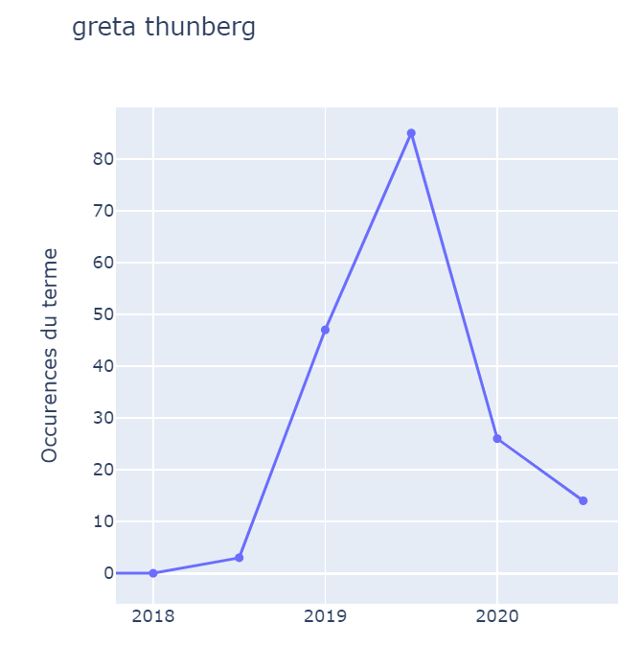

The graph A shows the number of occurrences of a term pro semester. In the first semester of 2019 it was used 47 times and in the second semester 85 times. Thus the use of the term has increased from the first to the second semester of the year 2019. But when looking at the graph, we have the feeling that the term’s popularity raises until mid-2019 and then starts to decrease during the second semester. In order to prevent such interpretation, we can shift the x-axis to the left of one semester unit.

Graph B

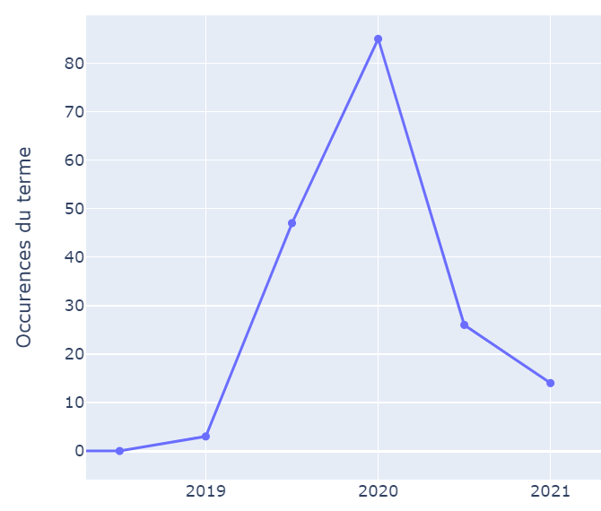This is what we get after that small modification (Graph B). The data are still the same, but here a point on the graph corresponds to the semester that is on its left. As an example, the maximum of the curve (above 2020) corresponds to the number of occurrences during the second semester of 2019. We see here that it is rising, which matches better the data set since the term’s use increased from the first to the second semester of 2019.

We study here dynamics, and the second graph makes it much easier to understand how the variations of the term’s popularity change.

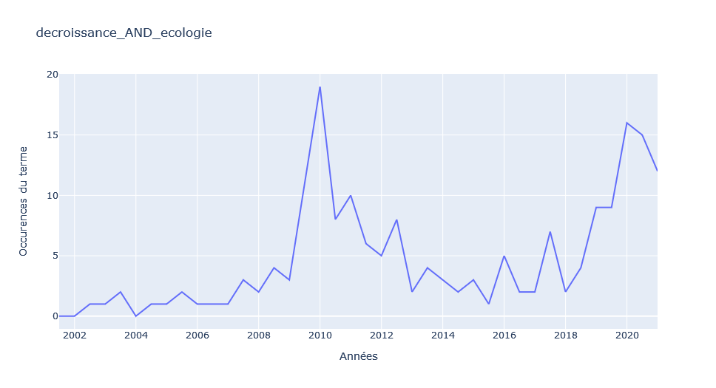**I - The “décroissance et écologie” graph as a starting point for our reflections on global trends/dynamics**

Graph C

We used the algorithm for different combinations of words: "décroissance et écologie" in the first place because it seemed to be a good marker of the recent and past debates about environmental issues, because *décroissance* is a political idea/project synonymous of ecological awareness linked with questioning the political, social and economic organisation of our societies. We searched for “décroissance et écologie” because we wanted to avoid articles speaking only about economic issues.

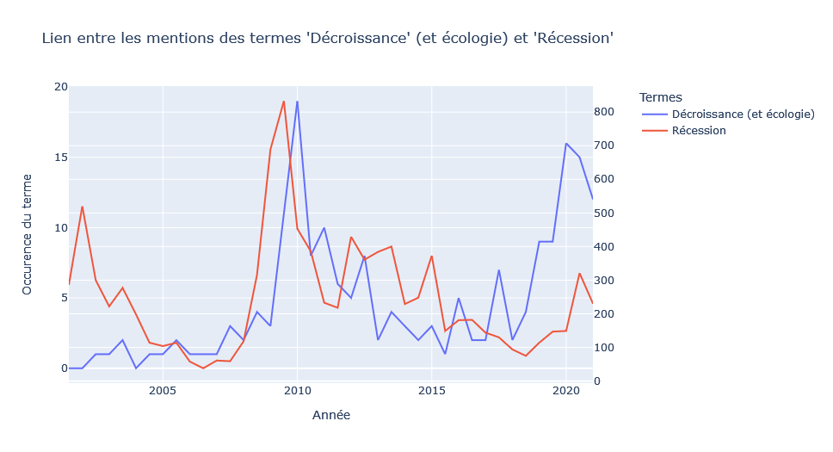We saw firstly two peaks in the graph “décroissance and écologie” (Graph C). The first peak was isolated in 2010 and we understood it as being clearly linked to the economic crisis developing since 2008. During this crisis, numerous debates about capitalism, the necessity of growth, and the role of the economy regained interest. We wanted to verify this hypothesis of a specific economic context explaining the peaks. We crossed the results of graph C with the number of occurrences of the word “recession”, standing for the public interest on the economic situation (Graph D).

Graph D

We can indeed see a clear correlation in 2009 and 2010 with a one year gap between the occurrences for “récession” and then “décroissance et écologie” following it. This means that the interest for the idea of *décroissance* was conjectural or that in this case, the possible in-depth social changes were triggered by the economic crisis (even if the mediatic interest did not reflect any clear changes after the end of the peak).

On the other hand, from 2018 to 2020, we have a second rise in the occurrences of the terms “décroissance et écologie". This peak is surely not linked to the new economic crisis because it is a rising tendency and the peak was already in 2019 (before the Covid-19 crisis and a new small peak for “récession” in 2020). We can think therefore that this time the increase in the mention of the term "décroissance" (linked with ecology, ie. the idea of political *décroissance*) in *Le Monde* articles is part of a deep-rooted social dynamic.

**II - Analysis of the deep-rooted movement:**

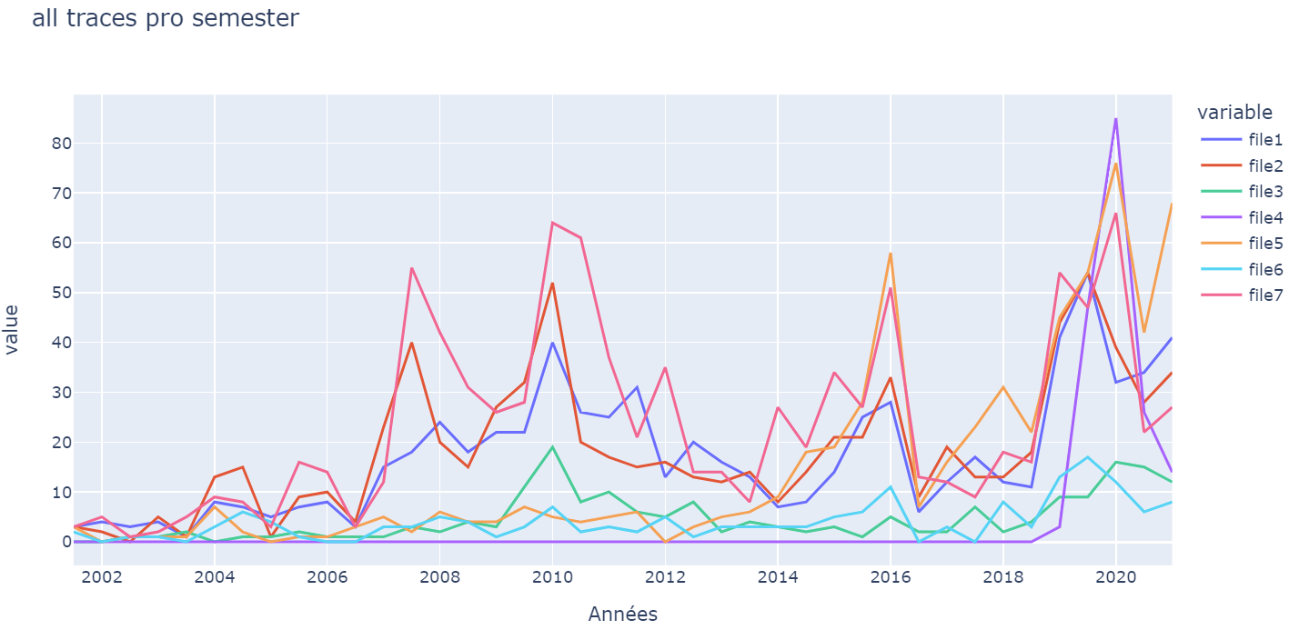In order to analyse the global dynamic for environmental interest, we aggregated all graphs representing tendencies of different terms we studied (Graph E).

File1 = 'changement climatique et écologie'

File2 = 'réchauffement climatique et écologie'

File3 = 'décroissance et écologie'

File4 = 'Greta Thunberg'

File5 = 'COP et climat'

File6 = 'dérèglement climatique'

File7 = 'catastrophe(s) climatique(s)'

Graph E

We can observe a global peak of interest around 2009, after the (begin of the) economic crisis in 2008. This corresponds to the peak we studied in the first paragraph.

Another clear peak of global interest happened in the end of 2015. The most plausible explanation for the sudden rise in interest appeared to us to be the COP21 and the signature of the Paris Agreement. We tested the occurrence of articles with the words “COP et climat” in order to verify this hypothesis (Graph F), and the rise of interest around the COP and the importance of the event strengthens our hypothesis.

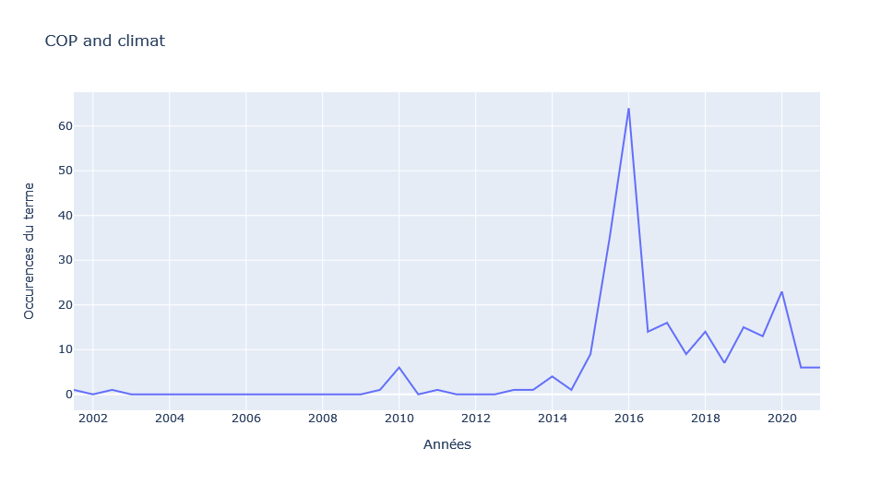The last major peak that we can observe in the Graph E happens around 2019-2020. We observe that nearly all curves peak around the second semester of 2019. From this date onwards, we see an interest or renewed interest in all ecological issues. As we have seen before, this peak happens before the outbreak of the Covid pandemic (and the following economic shock) happening in the first semester of 2020. Our main hypothesis concerning this peak (the biggest for most of the political terms) is the link with the growing climate strikes and protests (since the first *Klimatstrejka* of Greta Thunberg in the second semester of 2018), which became a central political movement and dynamic in 2019. The correlation is clear on the following graph. However, the question remains open for the causality relation: did the climate mobilisations created a rising interest/consciousness for the environmental issues or did a rising interest for climate change created a mobilisation that then reinforced the increasing dynamic around these topics?

Graph F

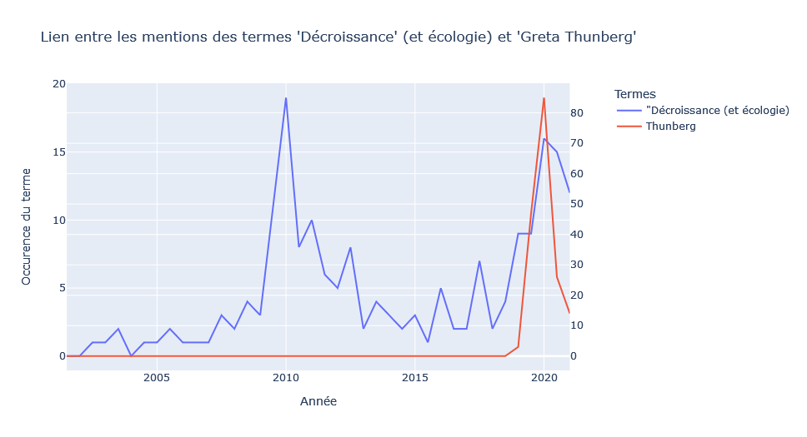From this we can ask what bottom movements appear in the first or second half of 2019. We can link these events to the climate protests that started in 2019. We can confirm the role of the climate protests in talking about ecology in newspapers by using the search term "Greta Thunberg". Greta Thunberg was the high school student who embodied the climate protests and the "Fridays for Future" movement. We see a big spike from 0 in 2018, to 85 articles citing her first name in the second half of 2019 (Graph G).

Graph G

From this the question remaining is what deep-rooted developed along those moments of rising interest which appeared after the economic crisis, the COP21 and along the climate mobilisations in 2019.

**III- Analysis of the dynamics of certain terms:**

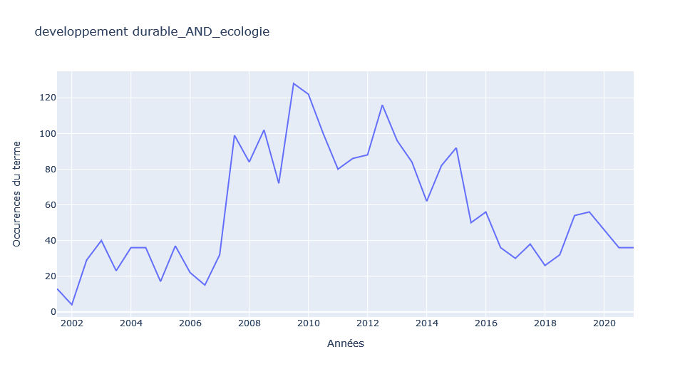Having conducted a quantitative analysis of interest in ecological issues, we will now seek to make a more qualitative analysis of this interest, looking at possible changes in political or social orientations towards ecological issues.

Graph H

First, the term "développement durable" has gradually lost popularity (Graph H). The highest number of articles using the terms "développement durable et écologie" was reached in 2009, with almost 250 articles that year using both terms. The term sustainable development has lost a lot of popularity, with only about 50 articles in 2020. This loss of popularity may be due to criticism of the concept. Indeed, sustainable development is based on three pillars: growth, ecology, and social issues. A critique of this institutional and growth-based concept has been developed. The concept of “sustainable development” gradually lost its meaning and its political force because it has been increasingly mobilized by institutional political and economic actors to describe their projects, without real changes. As a result, sustainable development is a concept that is used less and less by those mobilizing for the climate issue. We can verify this hypothesis of climate social dynamic more and more aware of greenwashing attempts and institutional capitalist communication by looking at the "croissance verte" graph. The number of articles in Le Monde referring to this term peaked in the first half of 2009, with 42 occurrences. By the first half of 2020, there were only 8 articles with this term. On the other side, other terms referring to other ways of life and alternative economic systems have gained in popularity. This is the case of the term "collapsologie" or the terms "décroissance et écologie" which have seen a resurgence of interest since 2019. We can globally see a political orientation of the public (or at least mediatic) discourse related to ecology, which seems to be more and more radical and in rupture with the growth-based economic system.

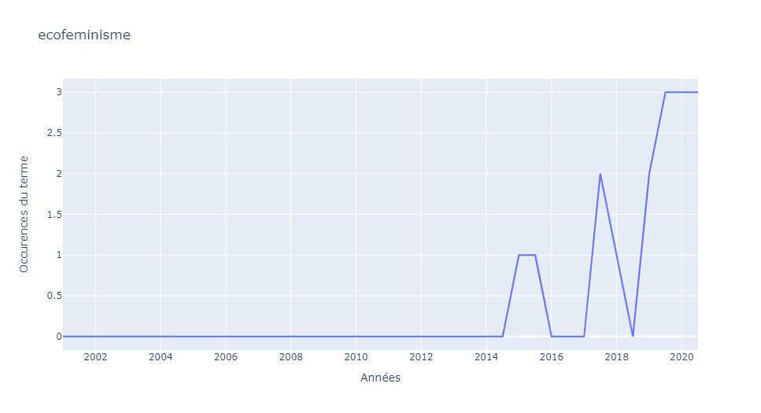We see a peak for some political terms that have clearly gained in popularity like "écoféminisme" (Graph I). We can see quite clearly the rise of the term ecofeminism from 2018 onwards. The curve continues to rise again in 2021 but we cannot take into account the data from 2021 because the years is not yet ended, and we can hypothesise that the candidacy of the ecologist Sandrine Rousseau, who describes herself as an "ecofeminist", has allowed the term to have a more important place in the public debate. 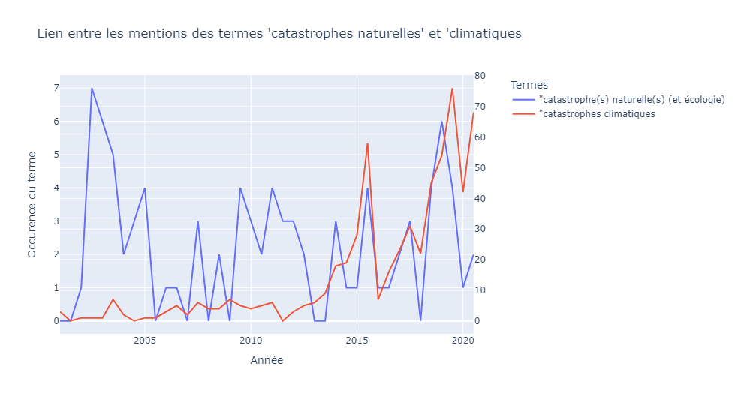

Graph J

Graph I

Concerning the terms "catastrophe naturelle ou catastrophes naturelles", the peaks seem to be independent of the global awareness on climate issues (Graph J). We could assume that these peaks depend on international or European disasters at least. The peaks in 2019 could be about fires in Australia, and for 2021 about floods in Germany.

However, the term ‘climate disaster’ started to be used and to gain momentum from 2015, which shows an awareness of the link between natural disasters and climate change.

**Conclusion**

The creation and use of the algorithm to see the occurrence of certain articles containing one or more terms has allowed us to show the growing interest for ecological issues since 2019, but also with peaks depending on the political or economic conjuncture before the more deep-rooted climate mobilizations. It has also allowed us to show the evolution and political dynamics of certain orientations of the ecological movement: "développement durable" or “green growth” are losing popularity and new terms such as "collapsologie" or "écofeminisme" are emerging.

We could imagine using our algorithm to provide data for further investigations in the economic and social sciences. We conceived our algorithm to be possibly useful and reused for future research and more globally as a tool easy to use for rapid analyses of social and political dynamics. For example, we could imagine focusing on feminist issues, and we could look at how the use of certain terms has changed since the MeToo movement.